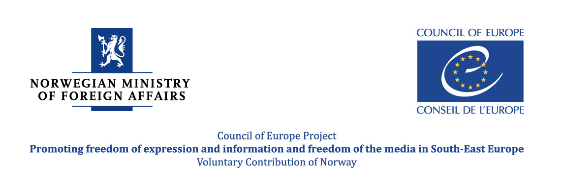


AGENDA

Regional Conference
Transparency in Media Ownership and Preventing Media Concentration

25-26 September 2014
Hotel Holiday Inn, Skopje

25 September 2014 –Thursday

09.00 – 09.30 Introductory remarks

Marta Arsovska-Tomovska, Deputy Minister, Ministry of Information Society and Administration
Zoran Trajchevski, Acting Director, Agency for Audio and Audiovisal Media Service
Lejla Dervišagić, Programme Manager, Media Division, Directorate General of Human Rights and Rule of Law, Council of Europe, Strasbourg

Moderator: Maja Stojanović, Project Officer, Council of Europe

09.30 – 10.00 Transparency in Media Ownership and Preventing Media Concentration: New Media Environment Challenges and Open Issues

Jean-François Furnémont, former chairman of EPRA and former Director General at Belgium regulatory authority

10.00 – 11.15 Brief presentations of the legal framework and current practices for ensuring transparency in media ownership and preventing media concentration in South-East Europe countries (participants from each country present experience of their country for maximum 20 minutes)

Moderator: Lejla Dervišagić, Council of Europe

11.15 – 11.45 Coffee Break

11.45 – 13.00 Continuation: Brief presentations of the legal framework and current practices for ensuring transparency in media ownership and preventing media concentration in South-East Europe countries (participants from each country present experience of their country for maximum 20 minutes)

13.00 – 14.30 Lunch

14.30 – 15.30 Discussion

15:30-16:00 Experiences and practices from implementing the anti-concentration measures and measures for protecting competition at the media markets: Germany

Bernd Malzanini, Head of Division, Commission for media concentration, Die medienanstalten – KEK, German regulatory authority

16:00 – 16:30 Experiences and practices from implementing the anti-concentration measures and measures for protecting competition at the media markets: Croatia

Damir Hajduk, Member of the Council, Agency for Electronic Media, Croatia

16:30 – 18:00 Panel discussion.
Possible topics for discussion:

- Legal framework development
- Legislation implementation
- Actions to be undertaken in case of hidden ownership
- Market competition protection mechanisms
- Difficulties when applying the rules regulating media concentration

Moderator: Jean-François Furnémont, Council of Europe Expert

26 September 2014 - Friday

09.00 – 10.00 Media ownership and media concentration – legislation challenges, experiences and practices
Peggy Valcke, Professor of Law, KU Leuven, Faculty of Law
10.00 – 11.00 Panel Discussion
11.00 – 11.30 Coffee Break

11.30 – 11:45 Media ownership and its impact on integrity of the media and journalism – conclusions and recommendations based on the research conducted by the SEE Media Observatory

Biljana Petkovska, Director of Macedonian Institute for Media, SEE Media Observatory partner

11.45 – 12:30 Discussion/ conclusions/future steps

Moderator: Lejla Dervišagić, Council of Europe

12.30 – 14.00 Lunch/End of the Conference

